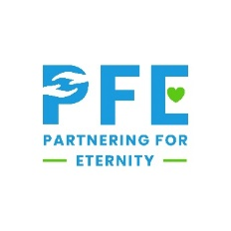
Commitment Form
Welcome to the Partnering for Eternity family! We are excited that you are participating in PFE this year. We hope you will make a difference in the life of your mentor, participate in service activities, and benefit from tuition assistance. To have a successful program year, we need both parent and student to be active participants in PFE.
Commitments
- Support your local PFE team in selecting a great mentor match for your child
- Understand student needs to visit mentor weekly for 14 weeks each semester
- Understand that if your student does not complete 14 QU’s, they will not receive scholarship funds
- Attend student/parent orientation
- Help your child set up an account on the reporting website
- Decide if you will transport/supervise weekly visits (you are responsible for them)
  - Communicate your plan with your local PFE coordinator
- Make sure your child follows the 24-hour reflection guideline
- Communicate with your local PFE coordinator about any concerns or challenges

Making these commitments is crucial to your child’s success in PFE.

I understand and agree to follow the PFE guidelines presented in the student/parent orientation and listed on sffcfoundation.org/pfe website.

Parent Name________________________________ Parent Signature_____________________________
Student Name_______________________________ Student Signature___________________________
Mentor Name_______________________________ Mentor Signature____________________________
*This form must be returned to your PFE coordinator prior to mentor visits starting.

